**TECHNICAL DESIGN DOCUMENT**

**PROJECT NAME:**

Smart Bus Crowd Detection System that uses AI-based Computer Vision

**ARCHITECTURE DIAGRAM:**

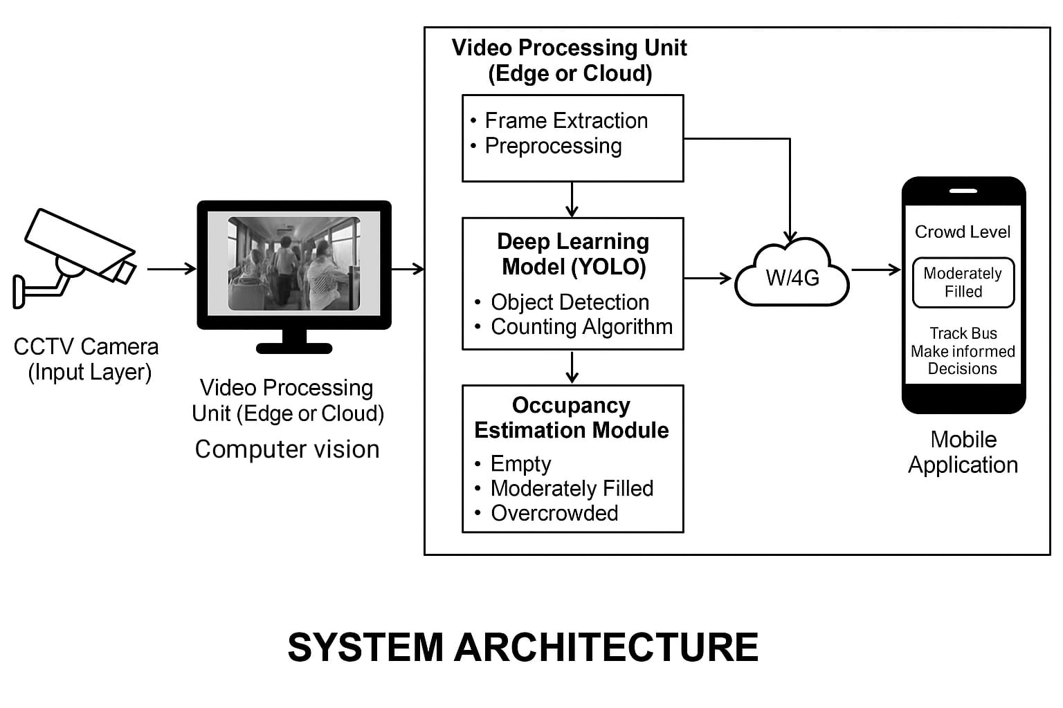

**DATA ACQUISTION AND PREPROCESSING WORKFLOW:**

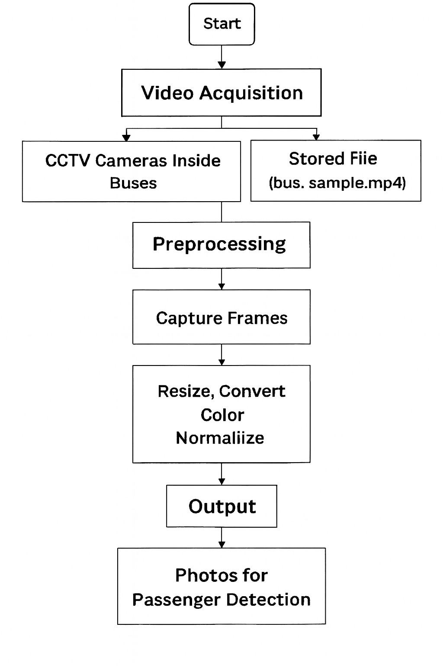

**MODULES:**

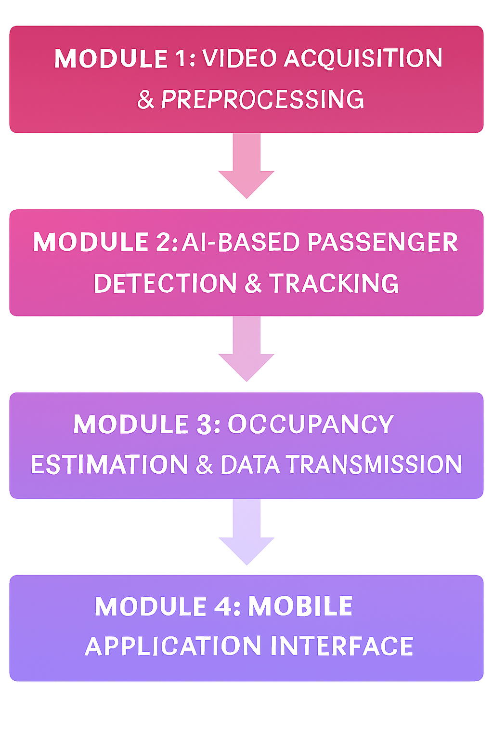

**HARDWARE USED:**

1. Processor: Intel i5 or higher



1. RAM: 8 GB (16 GB recommended)

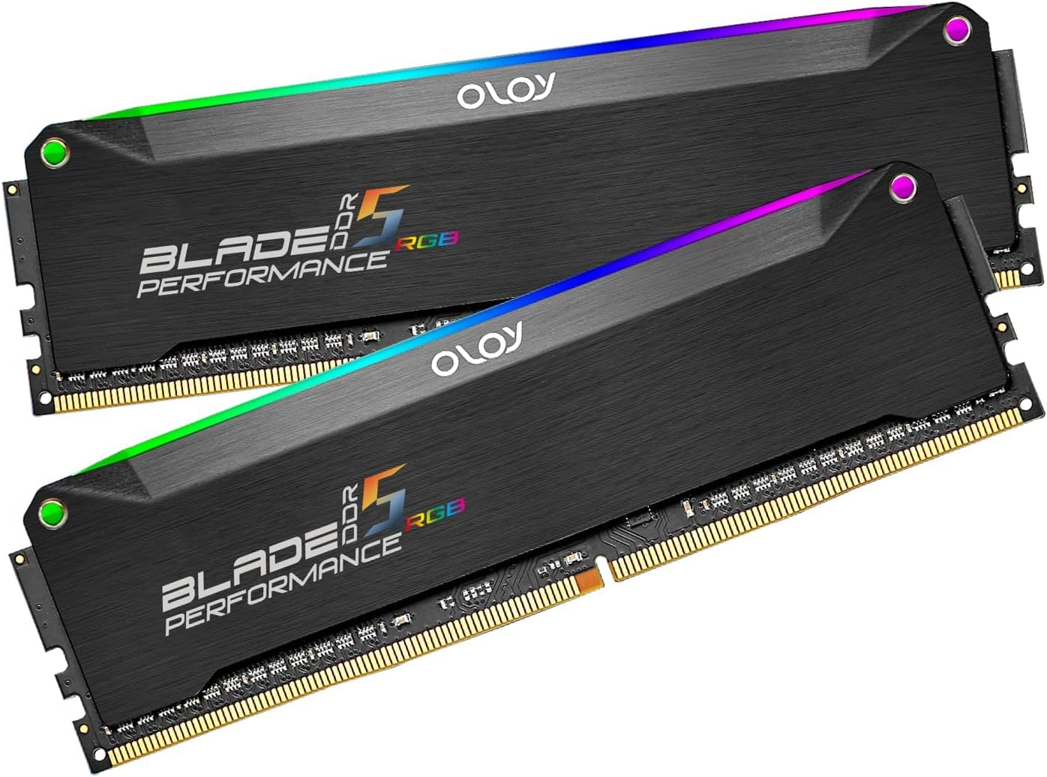

1. Storage: 256 GB SSDGPU: NVIDIA (for YOLO)

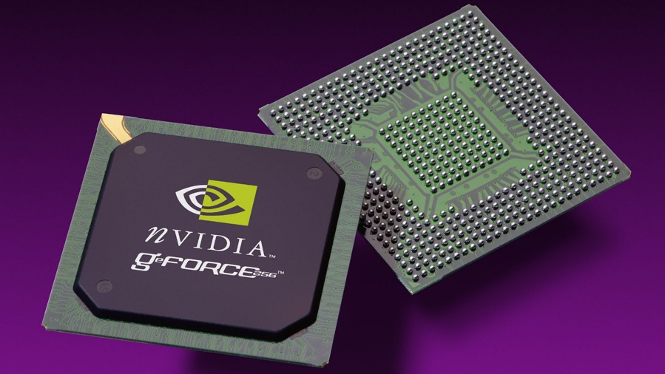

**DATA TRANSMISSION TO FIREBASE :**

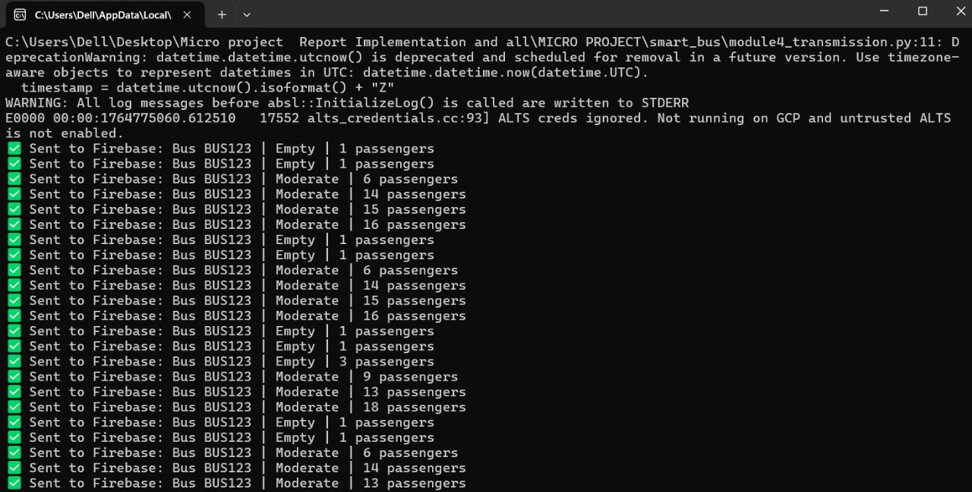

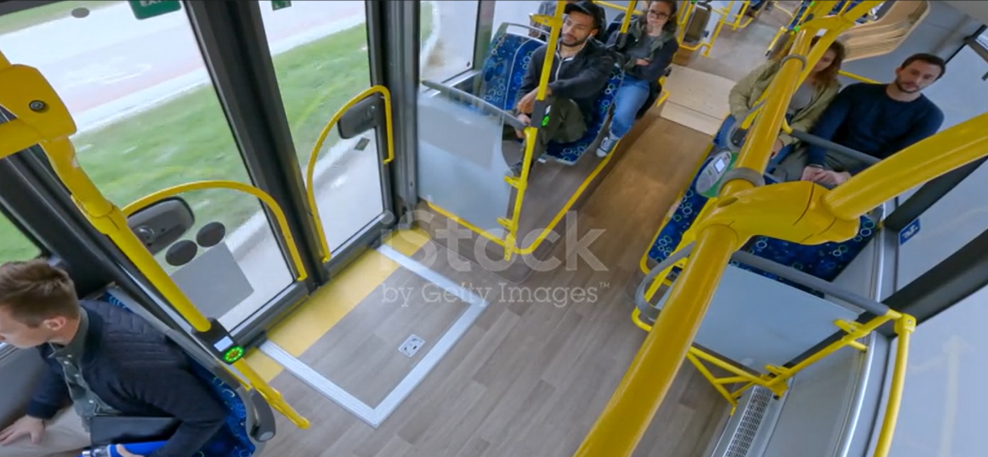

**APP SCREENSHOTS:**

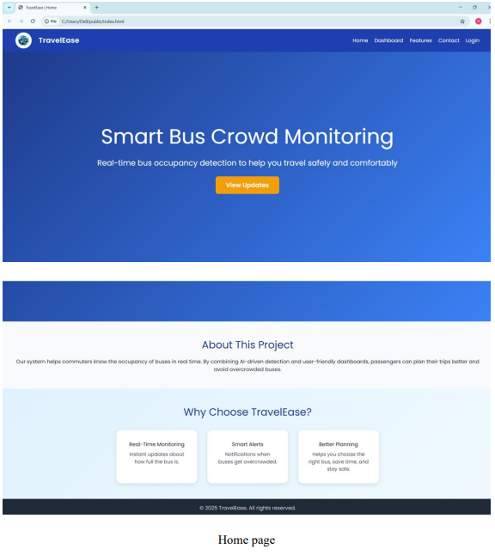

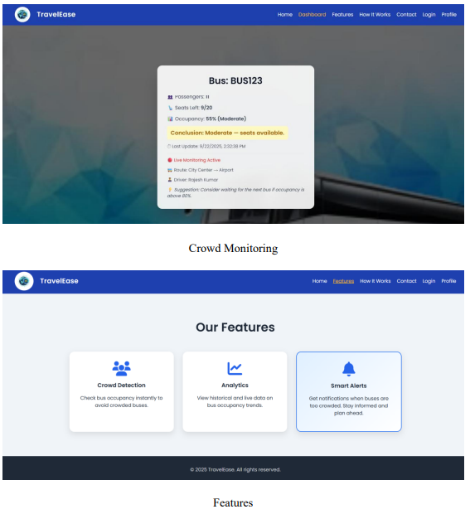

**LOGIN PAGE:**  


**PROFILE PAGE :**

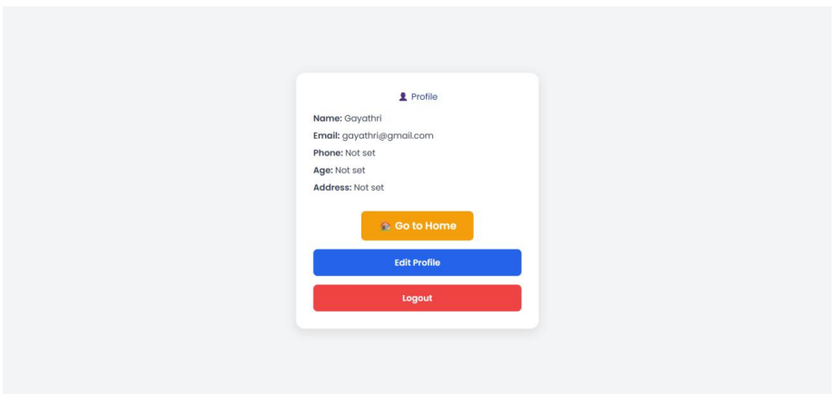

**RESULT SCREEN:**

